SQL Data Analysis Project Report

Project Title
SQL Data Analysis on E-Commerce Orders Dataset
Submitted By:
Ayush Mishra
Internship:
DecodeLabs Data Analytics Internship
Project No:
Project 3 – SQL Data Analysis

Objective
The objective of this project is to perform data analysis using SQL queries on an e-commerce orders dataset. The project focuses on extracting meaningful insights from customer orders, revenue, payment methods, products, referral sources, and order statuses using SQL operations such as filtering, sorting, aggregation, and grouping.

Dataset Description
The dataset contains e-commerce order information with 1200 records and the following fields:
- OrderID
- Date
- CustomerID
- Product
- Quantity
- UnitPrice
- ShippingAddress
- PaymentMethod
- OrderStatus
- TrackingNumber
- ItemsInCart
- CouponCode
- ReferralSource
- TotalPrice
The dataset was imported into PostgreSQL and analyzed using SQL queries.

SQL Queries and Outputs
Query 1: Orders with TotalPrice Greater Than 2000
SELECT *
FROM orders
WHERE totalprice > 2000; Screenshot:
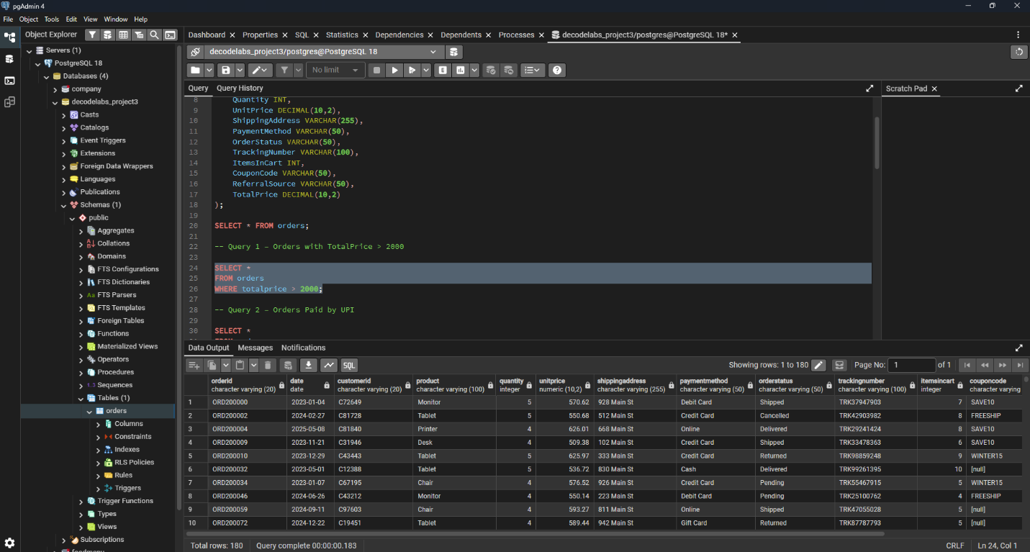

Query 2 – Payment Method
SELECT DISTINCT paymentmethod
FROM orders;

Screenshot:

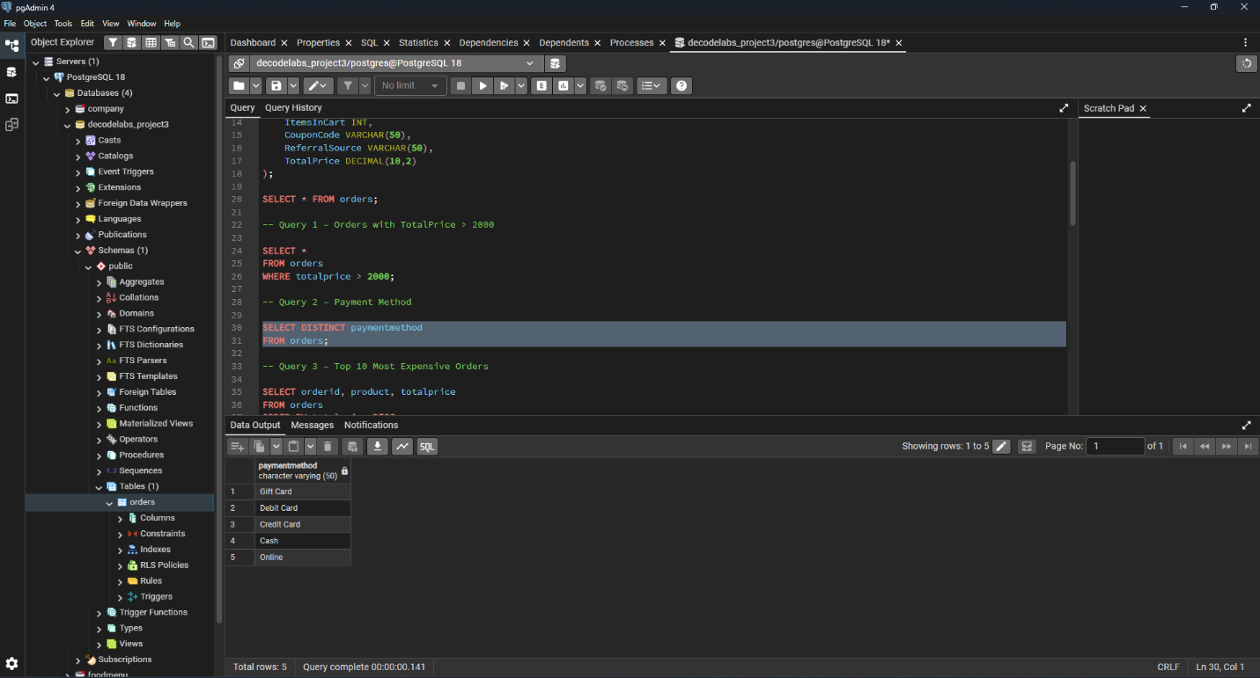

Query 3: Top 10 Most Expensive Orders
SELECT orderid, product, totalprice
FROM orders
ORDER BY totalprice DESC
LIMIT 10;

Screenshot:

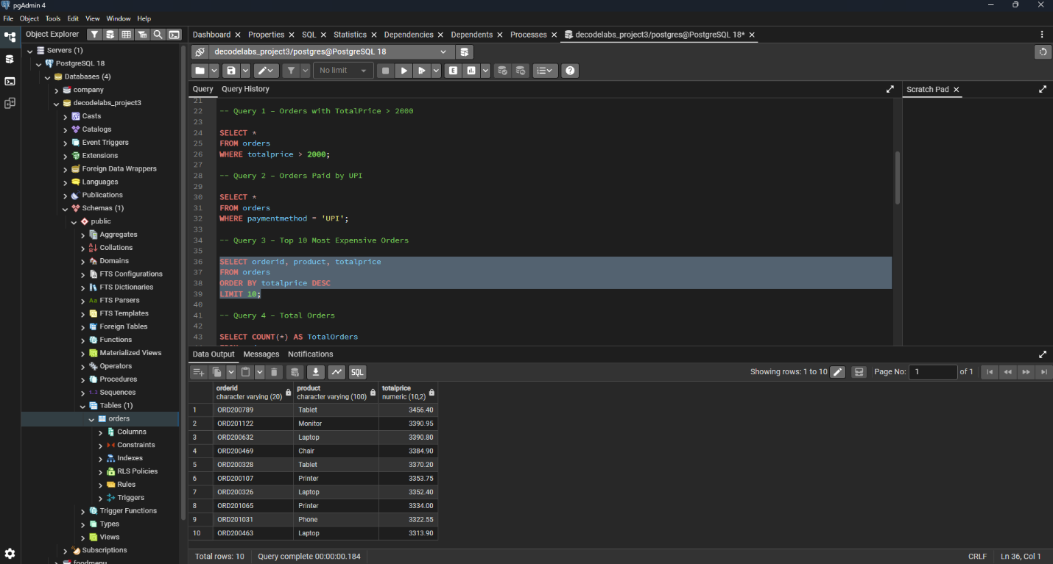

Query 4: Total Number of Orders
SELECT COUNT(*) AS TotalOrders
FROM orders;
Output:
1200

Screenshot:

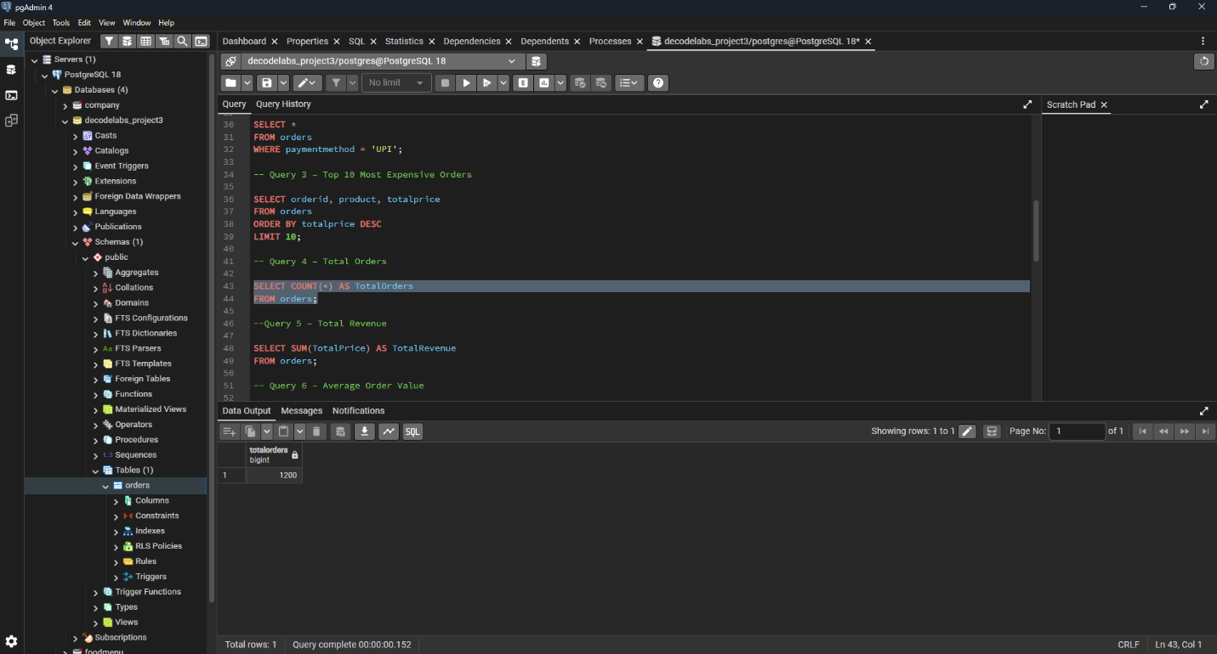

Query 5: Total Revenue
SELECT SUM(TotalPrice) AS TotalRevenue
FROM orders;
Output:
1264761.96

Screenshot:

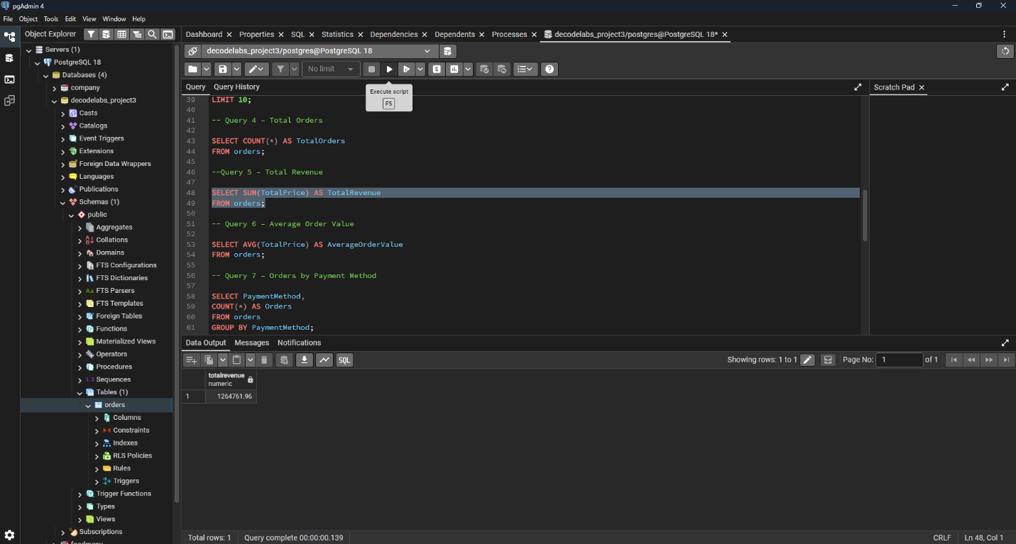

Query 6: Average Order Value
SELECT AVG(TotalPrice) AS AverageOrderValue
FROM orders;
Output:
1053.97

Screenshot:

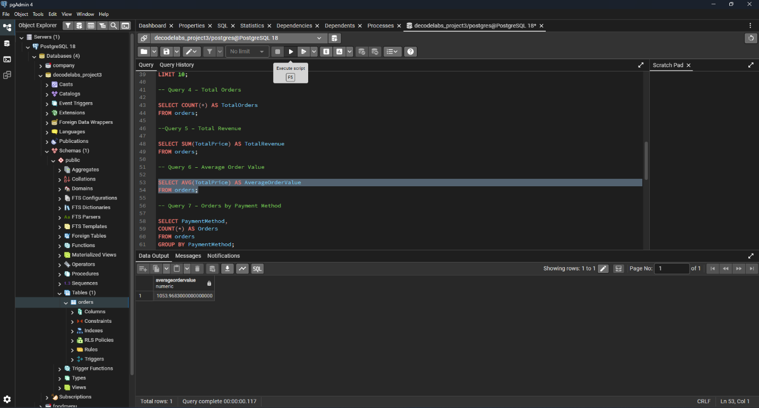

Query 7: Orders by Payment Method
SELECT PaymentMethod,
COUNT(*) AS Orders
FROM orders
GROUP BY PaymentMethod;

Screenshot:

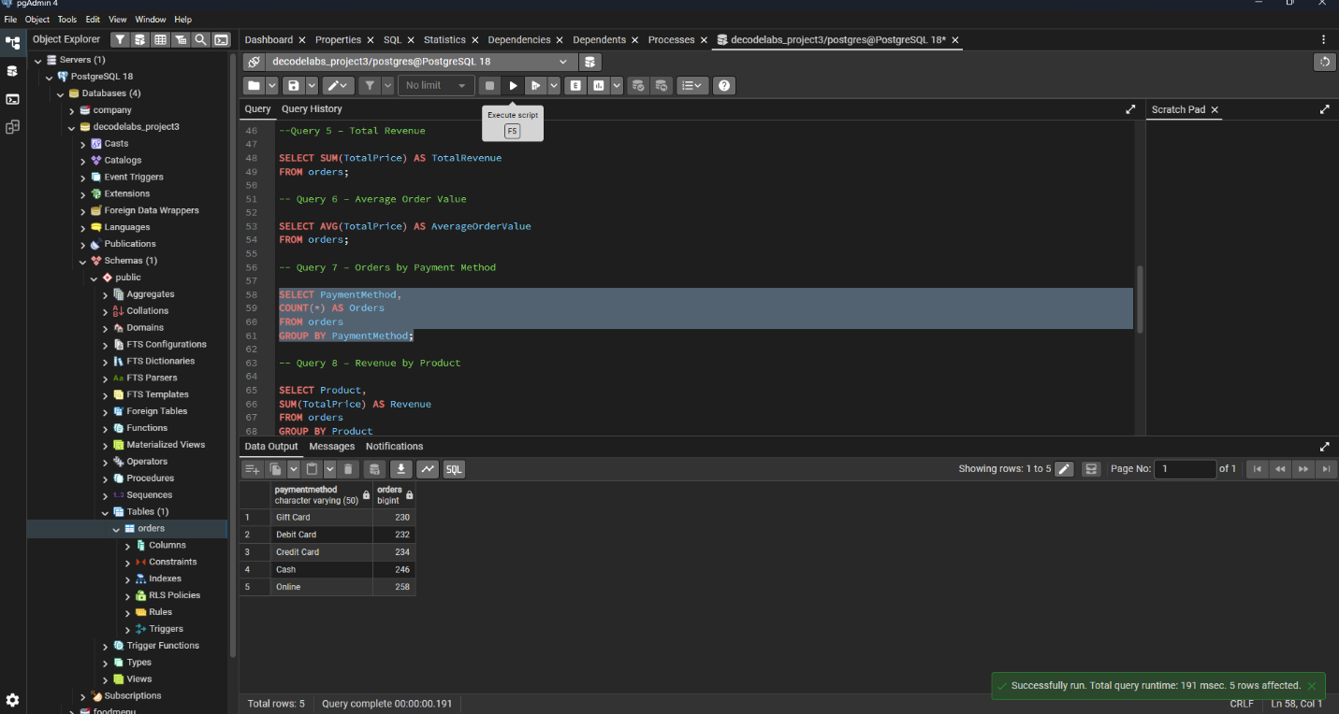

Query 8: Revenue by Product
SELECT Product,
SUM(TotalPrice) AS Revenue
FROM orders
GROUP BY Product
ORDER BY Revenue DESC;

Screenshot:

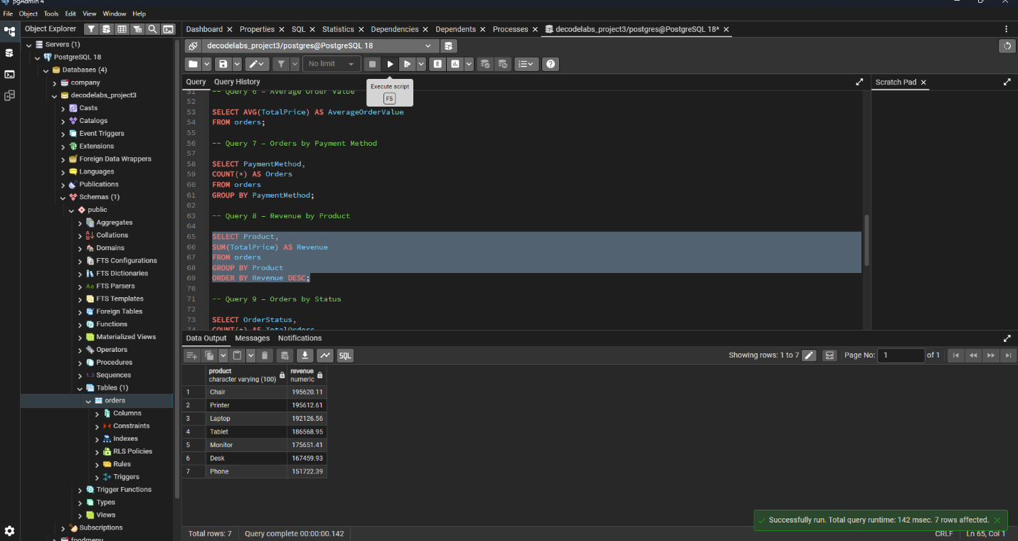

Query 9: Orders by Status
SELECT OrderStatus,
COUNT(*) AS TotalOrders
FROM orders
GROUP BY OrderStatus;

Screenshot:

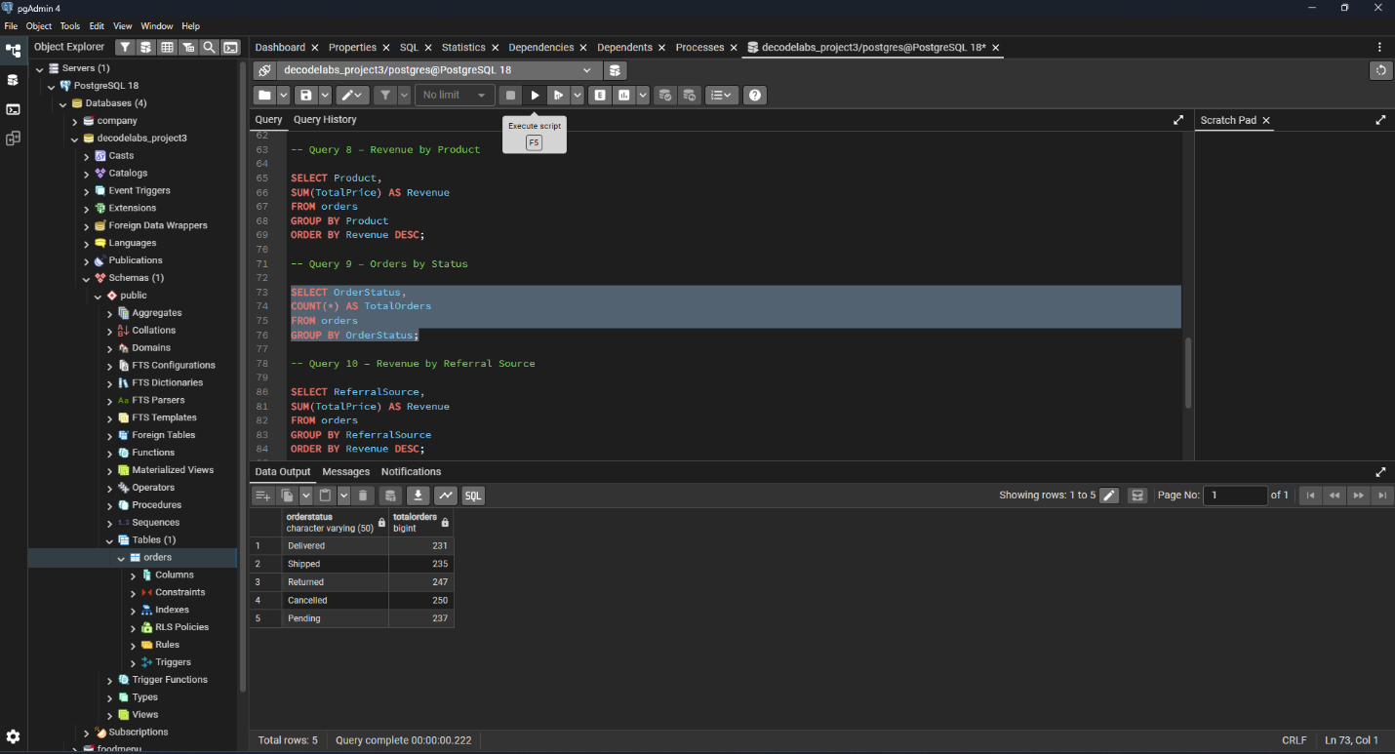

Query 10: Revenue by Referral Source
SELECT ReferralSource,
SUM(TotalPrice) AS Revenue
FROM orders
GROUP BY ReferralSource
ORDER BY Revenue DESC;

Screenshot:

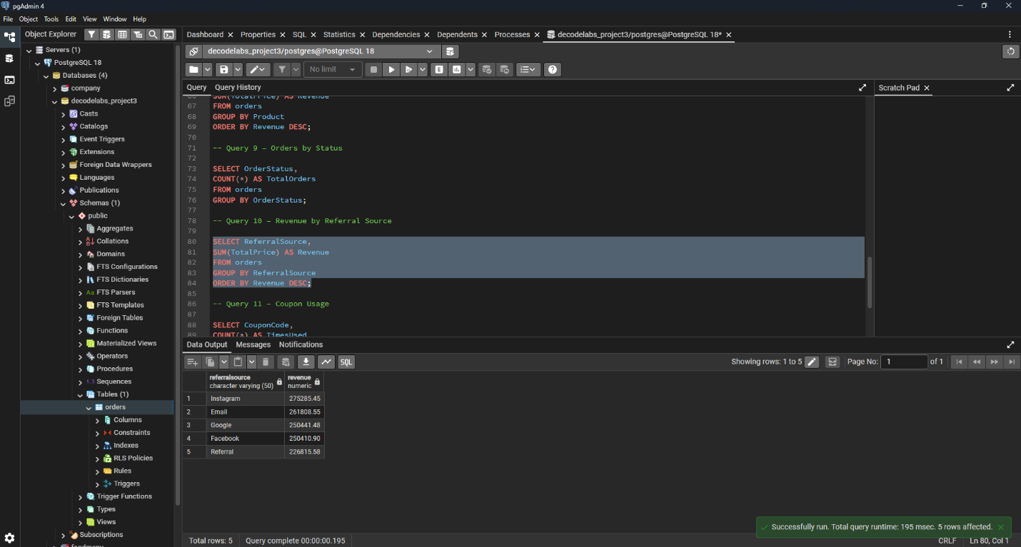

Query 11: Coupon Usage
SELECT CouponCode,
COUNT(*) AS TimesUsed
FROM orders
GROUP BY CouponCode
ORDER BY TimesUsed DESC;

Screenshot:



Key Findings
- The dataset contains a total of 1200 orders.
- Total revenue generated from all orders is 1,264,761.96.
- The average order value is approximately 1053.97.
- Online is the most frequently used payment method with 258 orders.
- Chair generated the highest revenue among all products.
- Instagram is the top referral source in terms of revenue generation.
- Cancelled and Returned orders account for a significant portion of total orders and should be monitored to improve customer satisfaction.
- Coupon analysis helps identify the most effective promotional offers.

Conclusion
This project successfully demonstrated the use of SQL for data analysis. Various SQL operations such as filtering, sorting, aggregation, grouping, and revenue analysis were performed to derive meaningful business insights from the e-commerce dataset. The findings can help organizations understand customer behavior, product performance, and revenue trends for better decision-making.

